 

**Going to SIA Convention - Japan 2018?**

We will order a Purple Pashmina Shawl for you. We want to stand out as a region and what better way than with a beautiful shawl**.**

**Sierra Nevada Region**

***Purple Pashmina Shawl***

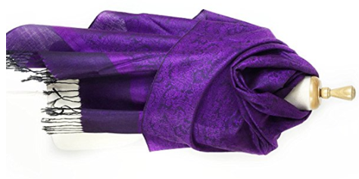Order Form

Name: _______________________

Email: ________________________

# of Shawls: ___________________

Payment method: ______________

Cost per shawl is **$12**

Return to Treasurer Pam:

3200 Red Rock Lane, Shingle Springs, CA 95682 by July 1st, 2018.

We will have it for you in Japan.